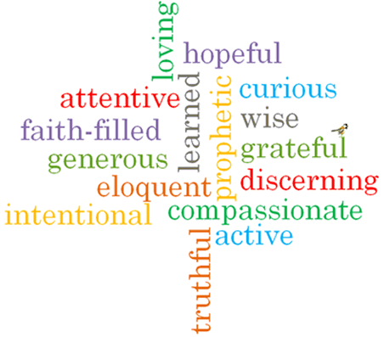
R
St Gabriel
What do we learn about Catholic Social Teaching from St Gabriel?
Feast day: September 29th
St Gabriel is a messenger of God.
Patron Saint of messengers, electronic communication, postal workers, those who work in TV and on the radio.

