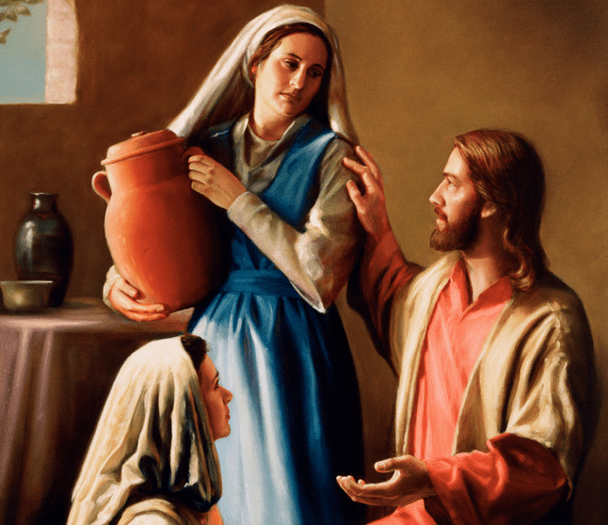

Y2
Feast day:
29th July
St Martha and St Mary welcomed Jesus into their home showing hospitality and love.
Patron Saint of the hospitality and domestic workers
St Mary and
St Martha
What do we learn about Catholic Social Teaching from St Mary and St Martha?

