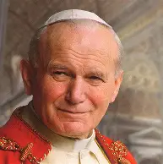
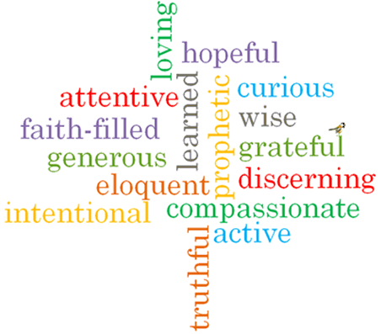
Y3
Feast day:
22nd October
St John Paul II was a Polish Pope who served with love, compassion and courage.
Patron Saint of World Youth Day, families, Poland and young Catholics
St John
Paul II
What do we learn about Catholic Social Teaching from
St John Paul II?

