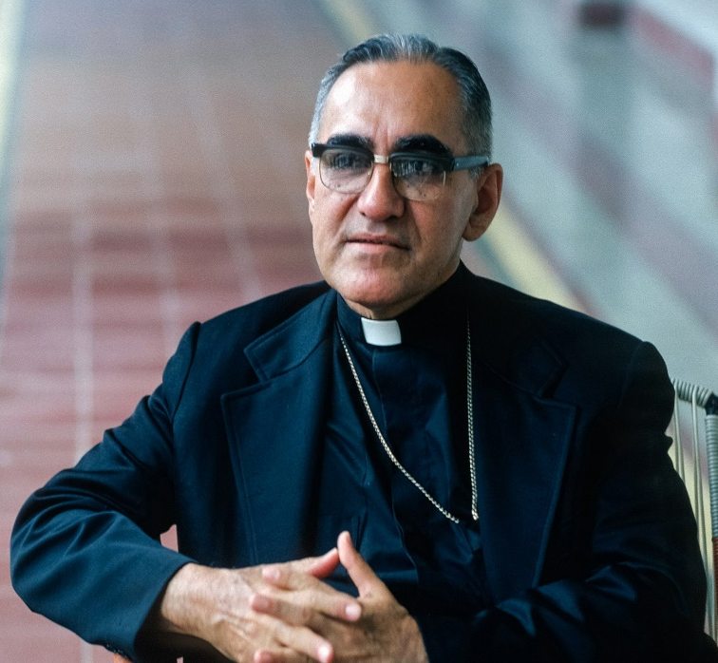

Feast day:
24th March
St Oscar was a Salvador archbishop, martyr and advocate for the poor.
Patron Saint of El Salvador, the Americas, persecuted Christians and the charity Caritas.
Y4
vv
St Oscar Romero
What do we learn about Catholic Social Teaching from
St Oscar Romero?

