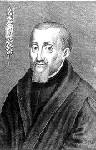

Feast day:
2nd March
The martyr, St Nicholas Owen, used his skills as a carpenter to help priests hide securely.
Patron Saint of families and domestic workers. Invoked as a protector.
St Nicholas
Owen
Y5
vv
What do we learn about Catholic Social Teaching from
St Nicholas Owen?

