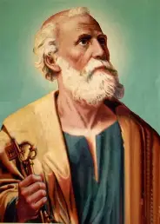

Y6
vv

St Peter
Feast day:
29th June
A Galilean fisherman, who became a disciple, apostle, the first Pope and later a martyr.
Patron Saint of the Catholic Church, Popes, Rome, Fisherman, Shipbuilders and netmakers.
What do we learn about Catholic Social Teaching from
St Peter?

