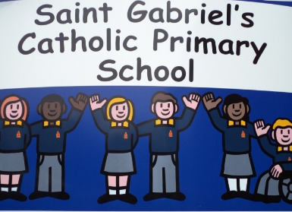
Saint Gabriel’s Catholic Primary School

EYFS Intimate Care Policy

St Gabriel’s is a welcoming school where:

We pray together, care for each other and learn together
we feel safe and respected
we try to do our best
everyone is treated fairly
We have fun with our friends.

With Jesus Christ at the heart of our loving Catholic community

INTENT STATEMENT

Reception will follow this procedure if the need arises.
We will not deprive any child starting in Reception due to them still wearing nappies/pull-ups.
We intend to change nappies/pull-ups at regular times during the sessions to ensure that no child is left feeling uncomfortable.

Aim
We aim to inform all parents that the school will come to an arrangement with them to allow their child to start Reception in nappies/pull-ups and also work together with parents to aid in potty training when the child is ready.

Method
Nappies/pull-ups are changed in the EYFS toilets or on the designated changing mats where there are facilities for staff to wash their hands.
- The child should be seated/stood safely while staff member washes their hands.
- The staff member will wear disposable gloves, mask and apron.
- Wet/soiled nappy/pull-ups will be removed.
- The child will be cleaned from front to back.
- Clean nappy/pull-ups should be secured on child.
- Wet/soiled nappy/pull-ups and all cleaning material will be double bagged and will be disposed of in the designated bin.
- Staff member and child will wash and dry hands.
- Changing mats as appropriate will be cleaned with anti-bacterial spray.
- The child will return to the classroom area.
- Privacy and dignity will be maintained during the time taken to change the child.
- Parents are asked to bring their own nappies/pull-ups, nappy sacks and wipes. However, school will have a supply of wipes and nappy sacks.

Joanne Coakley
EYFS Leader

Policy amended and reviewed: 09/09/2025
Next Review: September 2026

